**Rice Type Classification Using Machine Learning Algorithm**

**Project Title :**

Rice Type Classification Using Machine Learning Algorithm

**Objective:**

"To accurately classify the type of rice grain (e.g., White Rice,Brown Rice,Basmathi Rice) based on the visual features extracted from the uploaded image using a trained machine learning or deep learning model. This prediction enables quick, automated, and reliable identification of rice types for quality control, inventory management, and food authenticity verification."

**Problem Statement :**

Manual rice classification is slow, error-prone, and depends on human judgment, making it hard to ensure consistent quality. This project aims to build a machine learning model that automatically classifies rice types from images, helping to detect adulteration and maintain high-quality standards efficiently.

**Tools Used:**

* Python – Programming language for implementation
* Pandas, NumPy – Data manipulation and preprocessing
* Scikit-learn – Machine learning models and evaluation metrics
* TensorFlow / Keras – Deep learning (for image-based classification)
* OpenCV – Image preprocessing
* Jupyter Notebook – Development environment
* Streamlit – Web app deployment
* GitHub – Version control and code sharing

**Techniques Used:**

* Data Preprocessing – Handling missing values, normalization, encoding
* Feature Extraction – Manual for tabular data or CNN-based for images
* ML Algorithms – SVM, Random Forest, KNN, Logistic Regression
* Deep Learning – CNNs for automatic image classification
* Model Evaluation – Accuracy, Precision, Recall, F1 Score, Confusion Matrix
* Hyperparameter Tuning – Using GridSearchCV or manual tuning
* Deployment – Model export and user interface via Streamlit

**Dataset Used:**

* Dataset Name: C:\Users\puram\Downloads\RICE TYPES.zip
* Features: Input Image Shape, (Conv2D),MaxPooling Layer,Flatten Layer,Dense Layer (64 units),Output Layer.
* Target:The type or variety of rice grain based on its image.

For example-Basmathi,Brown,Red,Sona,White Rice.

**Workflow Summary:**

1. Dataset

* Used rice grain images organized by rice type in folders.
* Images are resized and normalized for model training.

2. Model Building

* A simple CNN model is created using Keras.
* Trained to identify rice types based on shape and texture.

3. Model Saving

* The trained model is saved for future predictions.

4. Streamlit Web App

* Users upload a rice grain image.
* The app shows the predicted rice type using the saved model.

5. Final Output

* Displays the name of the rice type (e.g., Basmati, Brown) instantly

**Demo Web App:**

* Open Anaconda Prompt
* Navigate to your project directory using the cd command  
  (cd C:\Users\puram\OneDrive\Documents)

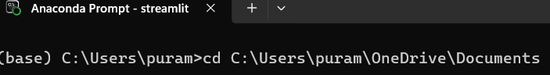

* Run the app using

streamlit run rice.py

* After running, Streamlit will display two URLs:

**Local URL**: http://localhost:8501→ Open in your own browser

**Network URL**: http://192.168.250.127:8501 → Use on other devices connected to the same Wi-Fi

**Code Execution:**

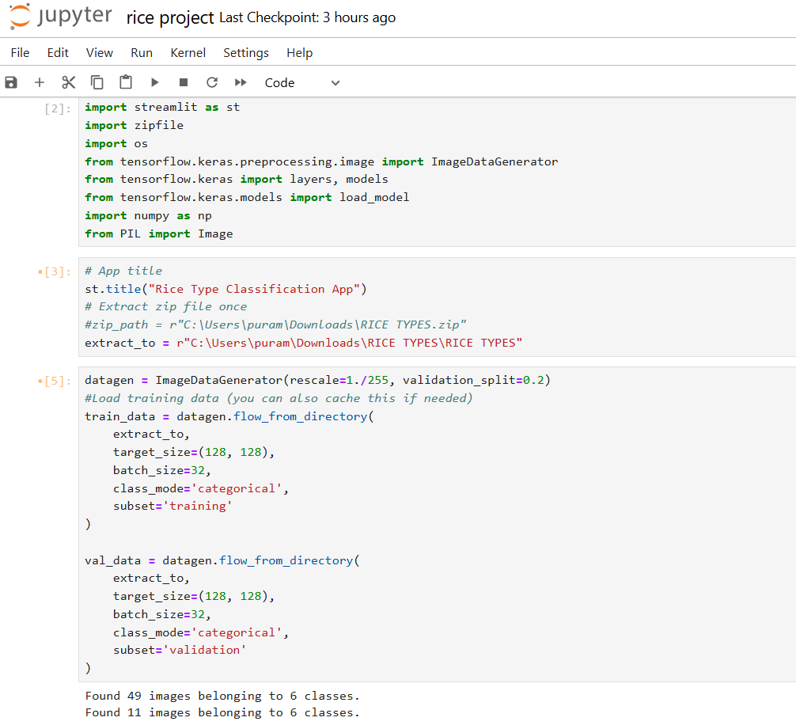

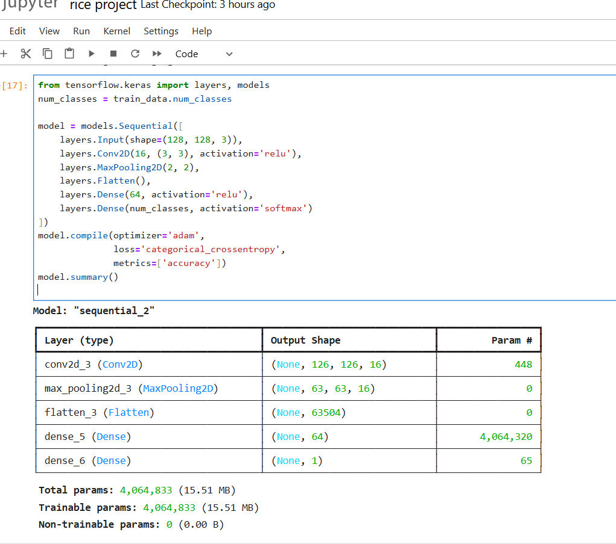

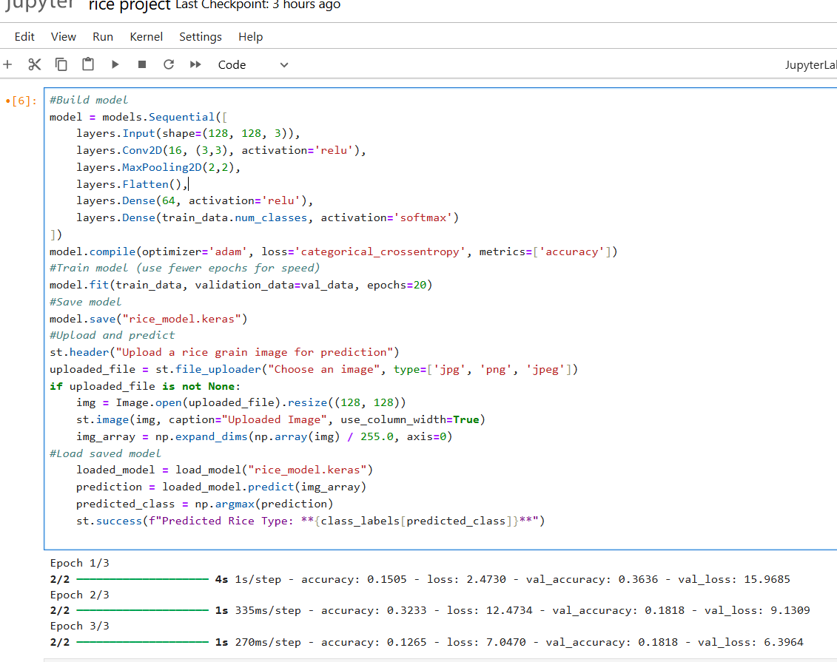

**Input and Output Overview:**

* Input: You are uploading an image file (e.g., White Rice 5.jpg)

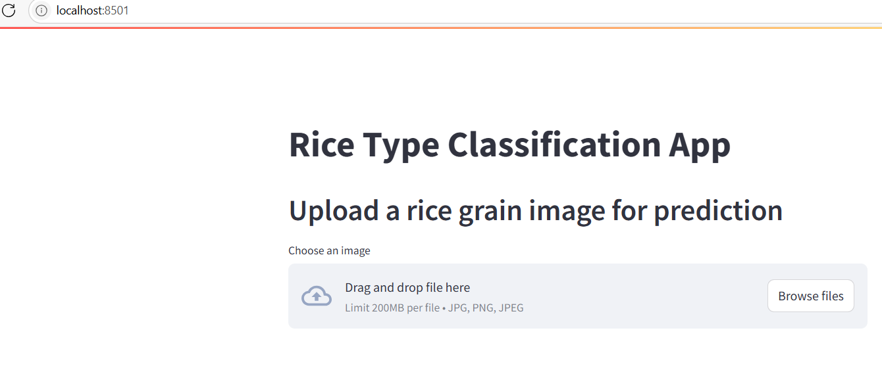

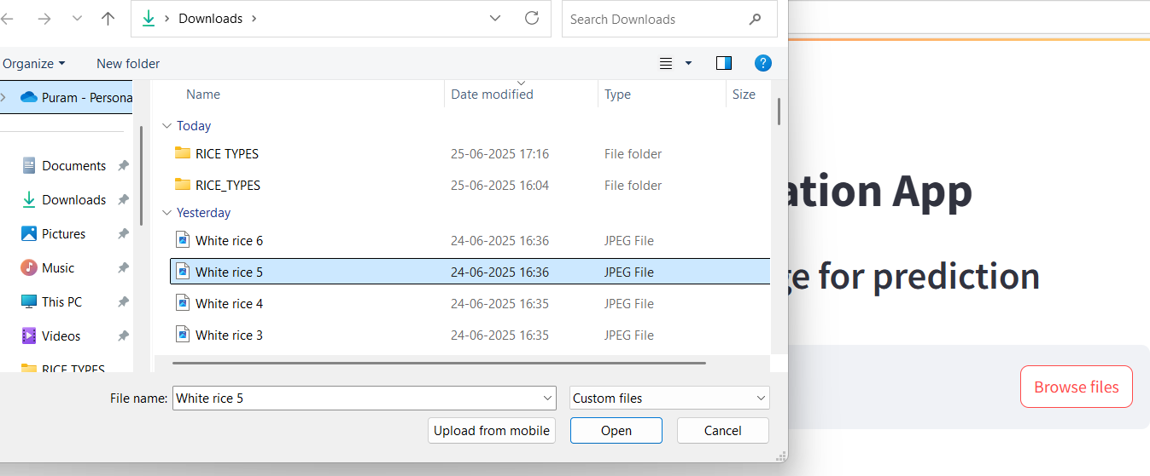

Output: Predicted the type of rice is White Rice

